Evan Tilley

elt2141

User Journey Map – Mushroom Website

**Person Interviewed:** Annie Sui. Pronoun: F

**User description**: Annie is a current Columbia student that may want to find out more info about the tunnels underground Columbia as there is a limited amount of information available to students concerning the tunnels.

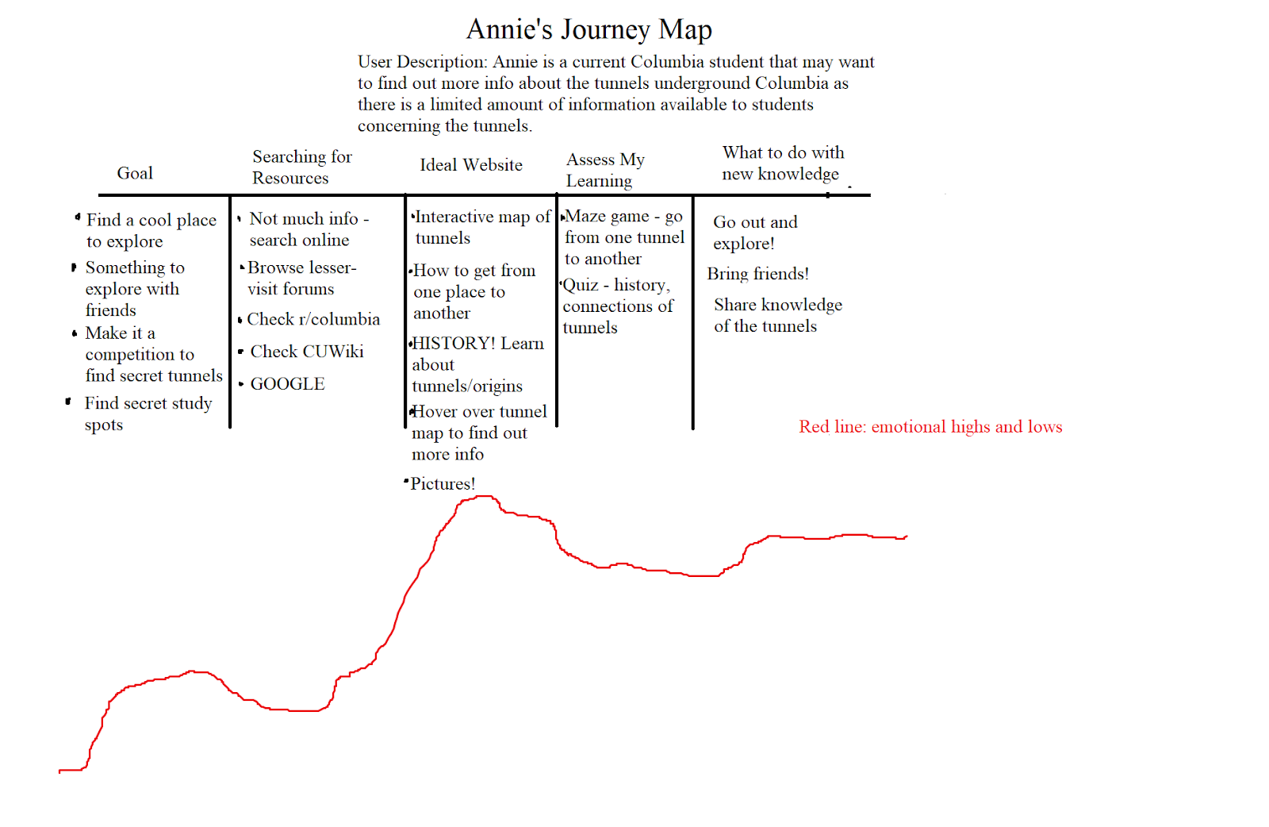

(insights and surprises below)

**Insights + Surprises**

This user journey interview was very helpful as it allowed me to gain some insight as to why a typical user might want to access the website, and what a user would expect. I noticed that Annie’s emotions were very high when discussing the actual content of the website, which was surprising and implied that users are very curious about information related to the site. Annie also pointed out several aspects of the website that she would enjoy, such as history of the tunnels and an interactive map, so my design will likely include these as I think a typical user would also value these features.